NRA Lump Sum Scholarship Procedure for Departments/Divisions

Scholarship payments made to a foreign national student are processed differently depending on the student’s tax status and U.S. presence. This procedure ensures foreign national students are paid and taxed appropriately.

To determine if a scholarship recipient is an international student, check information from department, student, SIS, and/or Common Scholarship Application (CSA).

Work with your divisional Scholarship Coordinator to ensure scholarship procedures are completed/finalized prior to payment.

Departments/Divisions are responsible for knowing if the scholar will be inside or outside the U.S. on the day the payment is issued. Scholars who are outside the U.S. may receive foreign source income (FSI), so additional documents are needed to be sure payments are taxed appropriately and scholars receive the correct tax reporting documents.

Verify international student’s tax status with No Empl ID

- If scholarship recipient does not have an Empl ID, enter appointment into JEMS Hire, check the box for “foreign national”, enter an email address for employee, and push into HRS.
  - Enter the appointment for one month on the A-Basis pay schedule. Title (Scholar-Y22NN or Fellow-Y21NN), Pay Group (ARF), Employee Classification (SA1), Pay Basis (L), and Earnings Code (SFF).
  - Update Reports to field in Job Data with the name of the Scholarship Coordinator and, if using, add a time approver on TL security page.
  - Department/Division HR office sends letter (draft attached) to recipient of scholarship about Glacier/foreign source income document requirement.
- When the scholarship recipient has an Empl ID, move on to the next section,’ Verify international student’s tax status with Existing Empl ID’.

OR
Verify international student’s tax status with Existing Empl ID

- With the scholarship recipient’s Empl ID, send email to glacier@ohr.wisc.edu using the Glacier team’s scholarship spreadsheet template to determine tax residency status.
  - Send email no later than two weeks prior to the payroll calc you wish to pay the scholar/fellow.
  - Email subject line should start with: XM (X=the month the scholarship should be paid) (Your Department Name) NRA Tax Status.
  - Spreadsheets will be reviewed on a first come-first serve basis.

- The Glacier team returns the spreadsheet within two business days. The action you take depends on these results:
Tax Residency Status | What Does This Mean? | Action Required
Resident Alien | Make payment as you would a U.S. citizen | Pay through the Bursar’s Office
Nonresident Alien | Scholarship must be taxed.  Glacier and/or Foreign Source Income (FSI) documents are required. | Process payment through HRS. **  Proceed to Step 3.
Incomplete | The Glacier team is unable to determine tax status when Glacier is incomplete. | The scholar should complete Glacier to the best of their ability. Resubmit spreadsheet when scholar completes Glacier.  If scholar is unable to complete Glacier, proceed to step 4b.
Permanent Resident or Naturalized Citizen | Make payment as you would a U.S. Citizen | Pay through the Bursar’s Office

**Remember, you must confirm with the scholarship recipient if they will be inside or outside the U.S. at time of payment.

- For any Nonresident Aliens (NRA) on the spreadsheet without a scholar/fellow appointment, enter appointment into JEMS Hire, check the box for “foreign national”, enter an email address for employee, and push into HRS.
  - Enter the appointment for one month on the A-Basis pay schedule. Title (Scholar-Y22NN or Fellow-Y21NN), Pay Group (ARF), Employee Classification (SA1), Pay Basis (L), and Earnings Code (SFF).
  - Update Reports to field in Job Data with the name of the Scholarship Coordinator and, if using, add a time approver on TL security page, if using.

- If scholar is inside the U.S. when payment is issued, proceed to step 5.

If scholar is outside the U.S. when payment is issued, proceed to step 4a.

4a. Collect and review updated Glacier documents, an I-94 Travel History and Foreign Source Income Statement for accuracy then upload to Campus Payroll Box and proceed to step 5.

  - Refer to Division Responsibilities for Paying Foreign Nationals outside the United States for more detail about reviewing and uploading documents.

Document Details:

An I-94 Travel History is created by U.S. Customs and Border Protection. It includes an employee’s arrival and departure history for the past 5 years. This will be our proof that the scholar is outside the country.

    - The I-94 must include all entries and departures. If an entry and/or departure is not listed, the scholar must write them in with dates.
    - If the scholar has not been to the U.S., they will not have an I-94 travel history. They should search their passport information on the USCBP site and submit a screenshot of their ‘no results found’.
    - The scholar must also write ‘This travel history is accurate to the best of my knowledge.’ Then sign and date.
    - If a scholar changed passports in the last 5 years, they must provide an I-94 travel history for both passports.
Example of Complete I-94 Travel History: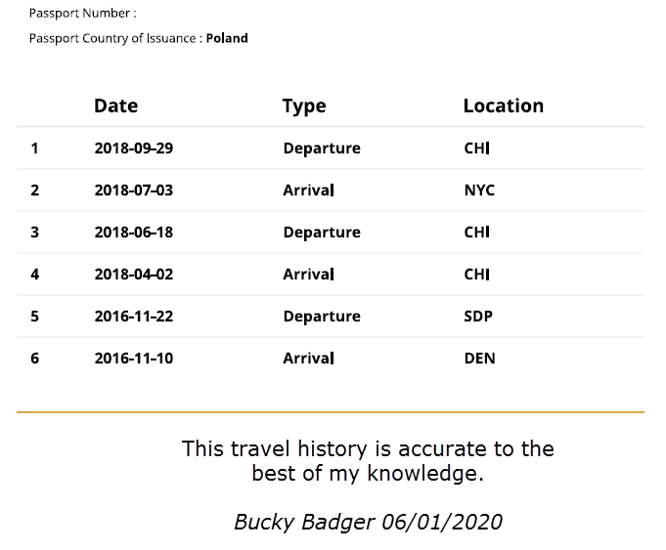

Example of Incomplete I-94 Travel History:
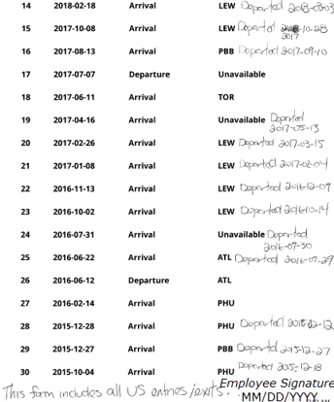
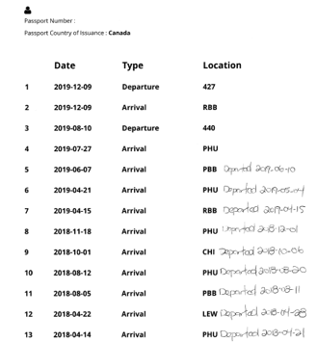

This I-94 had missing departures, so the employee wrote in the missing dates to make it complete.

A Foreign Source Income Statement contains all current year planned and potential visits. This includes possible visits on any visa type. If they are hoping to come to the U.S. at all, they should include the tentative visit dates.

      - Number of days present should match those listed on I-94 travel history
      - If no completed or planned visits in the current year, employee should write ‘0’ in the number of days in the U.S. column.
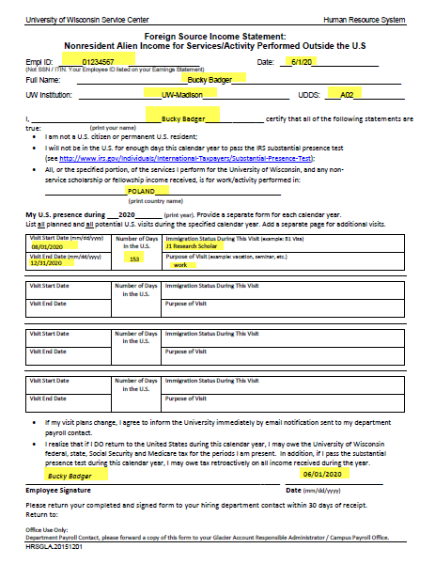

4b. Collect and review the below documents for accuracy, then upload to Campus Payroll Box and proceed to step 5.
  - Refer to Division Responsibilities for Employing Foreign Nationals outside the United States for more detail about reviewing and uploading documents.

Documents Needed:
These documents will allow OHR Payroll to determine the scholar’s tax residency status and their U.S. presence.
  - I-94 Travel History. See details in step 4a.
  - Foreign Source Income Statement. See details in step 4a.
  - Nonresident Alien U.S. Visit Summary. See below for details.

Document Details:

A Nonresident Alien U.S. Visit Summary provides us with the information that we are unable to capture through a Glacier account update.
          - Lists all U.S. visits since 1986 on an F or J visa
          - Lists all U.S. visits in the current and previous two calendar years, regardless of immigration status.
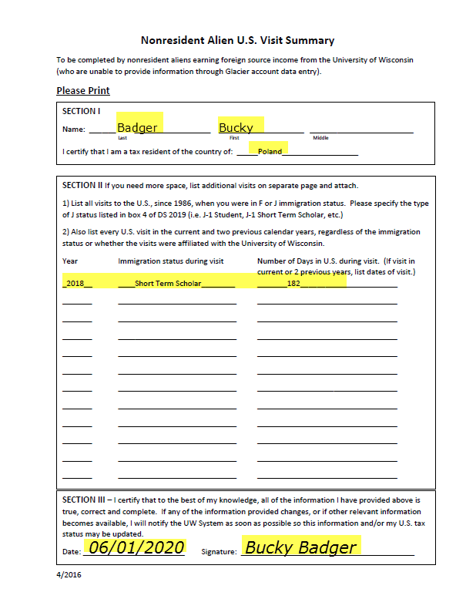
- Department/Division enters lump sum in HRS as Additional Pay (see KB 17094).
  - If the recipient is outside the U.S., please indicate that in the addl pay description.
  - The Add’l Pay should be entered and approved prior to the first paysheet creation to ensure payment processed by the monthly calc.
  - Enter the funding of the Add’l pay into HRS. (FYI Do Not Use Program Code 9.) Funding can be entered as soon as the Oracle email with the Empl Rcd # is received.
- Scholarship Coordinator approves as level 1 Workflow for Additional Pay approver.
- OHR reviews the addl pay at level 2.
  - RA = denied at level 2. Pay through the Bursar’s Office.
  - NRA with all documents submitted = OK to Pay. OHR Payroll approves as level 2 workflow approver, the Add’l Pay will pay out on the next payroll.
- End of Process.

Other Considerations:

            - United States bank accounts are the preferred, most efficient method of payroll. Divisions should confirm with scholars that they have access to a United States bank account. For scholars outside the U.S. without a United States bank account, divisions must collect and submit wire transfer information. See Division Responsibilities for Paying Foreign Nationals outside the United States for detailed wire transfer information.
            - Foreign Source Income documents must contain original signatures. UW System will not accept electronic signatures.
            - Check the JEMS box that indicates the scholar is a foreign national. Do not check the Foreign National Working outside the U.S. box in Modify a Person or in JEMS. This is a centrally managed function.
            - Another division may be employing your scholar who is outside the United States. If that is the case, coordinate with that division to avoid duplicating efforts.
            - Tax residency status must be verified each semester. See column on NRA Scholarship spreadsheet for change date as a useful guide.

