

**HR Representatives: Guidance on Creating a Google Hangouts Meeting to Verify I-9 Section 2**

Creating a Google Hangouts video meeting via Outlook

* 1. Create a new calendar appointment.
  2. Locate the Hangouts Meet icon in the toolbar.  Select Add Meeting. (See information in Appendix to add Hangouts Meet to your toolbar.)

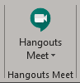

* 1. The following information will be added to the email:

Hangouts Meet

**Hangouts Meet joining info**

<https://meet.google.com/drn-etbh-ovm>

Or dial: +​1​ ​9​0​4​-​7​1​7​-​5​1​2​8 PIN: 2​8​2​ ​xxx​ ​xxx​#

First time using Meet? [**Learn more**](https://gsuite.google.com/learning-center/products/meet/get-started/#!/section-2-3?hl=en-US)

* 1. Update the appointment accordingly.  Press Send.
  2. To start the meeting, click on the link in the invitation.  The Google meeting will open in a web browser.  Click Join Now or Present to start the meeting.

More Info

* G Suite Learning Center: [Hangouts Meet training and help](https://support.google.com/a/users/answer/9282720?visit_id=637207469942985792-1944077668&rd=1#!/section-2-3?hl=en-US)

Other collaborative tools available

* [WebEx](https://it.wisc.edu/learn/guides/getting-started-with-webex-meetings/)
* [MS Teams](https://kb.wisc.edu/office365/page.php?id=73588)
* [Skype](https://kb.wisc.edu/6773)
* Zoom



**New Employees: Guidance on Joining a Google Hangouts Meeting to Verify I-9 Section 2**

Joining a Google Hangouts meeting

1. Invitees of a Hangouts video meeting will receive with the following email:

Hangouts Meet

**Hangouts Meet joining info**

<https://meet.google.com/drn-etbh-ovm>

Or dial: +​1​ ​9​0​4​-​7​1​7​-​5​1​2​8 PIN: 2​8​2​ ​xxx​ ​xxx​#

First time using Meet? [**Learn more**](https://gsuite.google.com/learning-center/products/meet/get-started/#!/section-2-3?hl=en-US)

1. To join the meeting, click on the link in the invitation.  The Google meeting will open in a web browser.  Click Join Meeting to enter the meeting.

More Info:

* An invitee can connect to the meeting on a mobile device or a computer with a camera.
* G Suite [Joining a Meeting](https://www.youtube.com/watch?v=56AbXLlzPpY&list=PLU8ezI8GYqs6sCUWKaCVBaVg-ND6uH2BG&index=3&t=0s) How to Video

**Appendix: Adding Google Hangouts Meet to Outlook**

Outlook Desktop Client: Adding Google Hangouts Meet

1. Within the Outlook desktop client locate the Get Add-ins button in the toolbar.

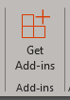

1. Within the Add-ins window, search for hangouts

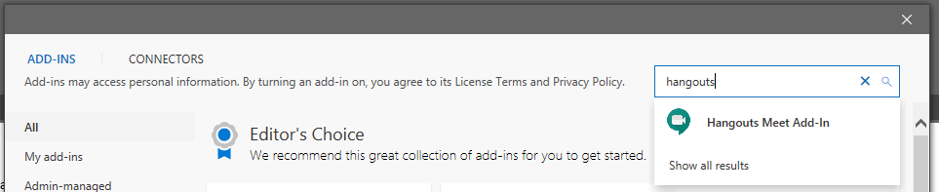

1. Click Add

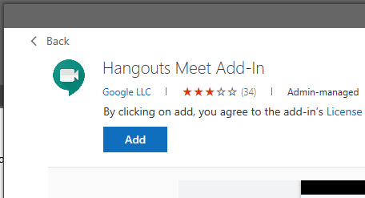

Outlook Web App (OWA): Adding Google Hangouts Meet

1. Go to <https://email.wisc.edu/login/> to access Outlook online.  Go to the Calendar and click the New Event button.



1. In the Calendar event window locate the “…” button and select Get Add-ins
2. Within the Add-ins window, search for hangouts

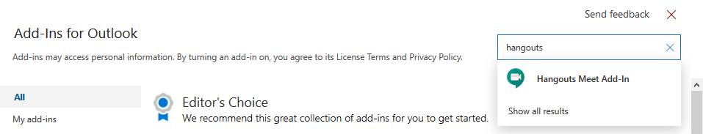

1. Click Add

