Entering Paid/Unpaid Visiting Titles in JEMS/HRS
Contents
Find/Add Hire Tab 1
Person Tab 1
Person Contact Tab 2
Position Tab 2
Job Tab 3
Benefits Tab 4
HR Contact Tab 4
Comments Tab 5

Find/Add Hire Tab
- Recruitment Type: No Associated PVL/Waiver
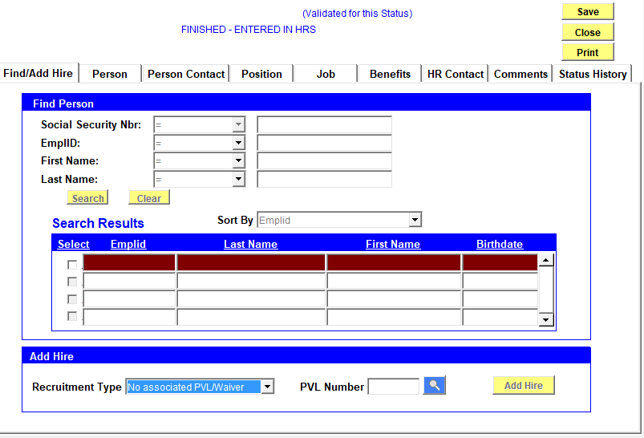

Person Tab
- Effective Date
- First/Last name as appears on their identification card
- Date of Birth and Gender
- Leave ACSD blank
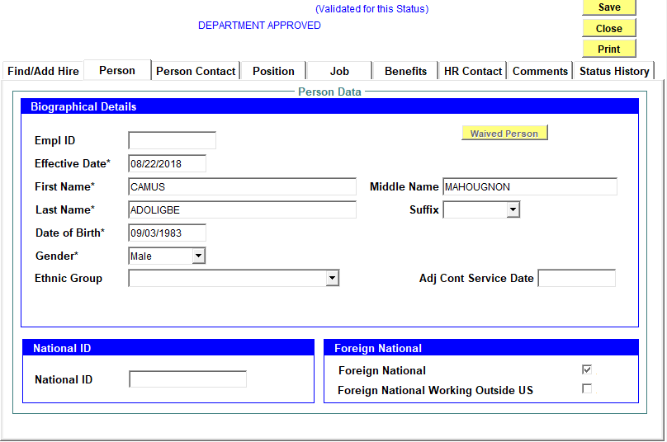

Person Contact Tab
- Use your department’s address from drop-down menu as default address
- Home address should be a local address, not an international address
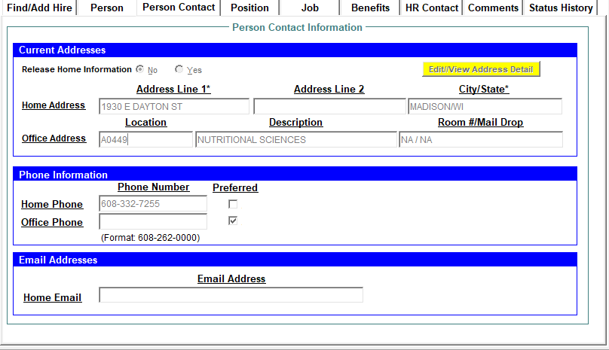

Position Tab
- Be sure to enter a “Reports To”
- FTE: 0 (If unpaid)
- Dept is in “drop down” list
- Empl Class: OT4
- Job Code: Z90NN
- FLSA Status – blank
- Select Continuity
- Back up for limited appt – always “no”
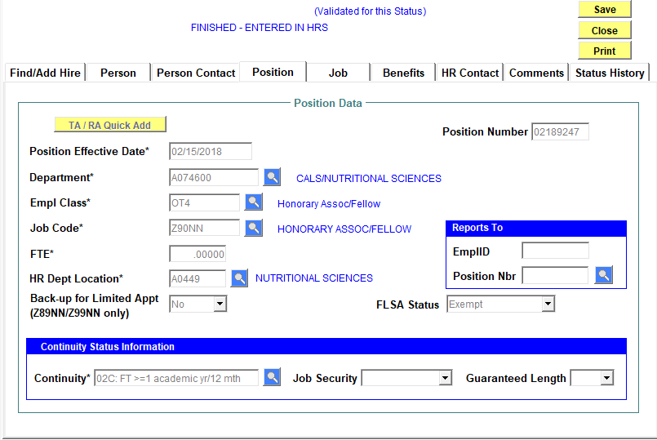

Job Tab
- Hire: Effective Date
- Expected Job End Date is important because visiting/honorary appointments are fixed-terminal appointments
- *No Pay Basis/no position of trust
- *If hiring a visiting scientist or professor, pay basis usually is A
- Use UTG guidelines and enter FTE
- A criminal background check is required for paid visiting appointments
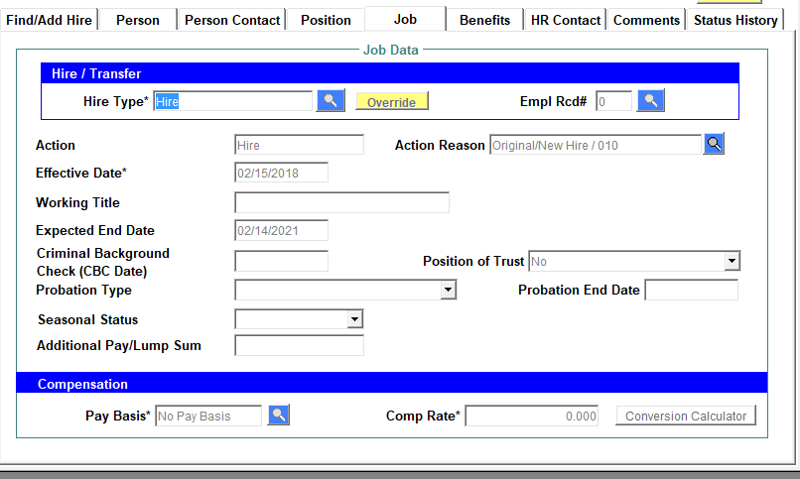

Benefits Tab
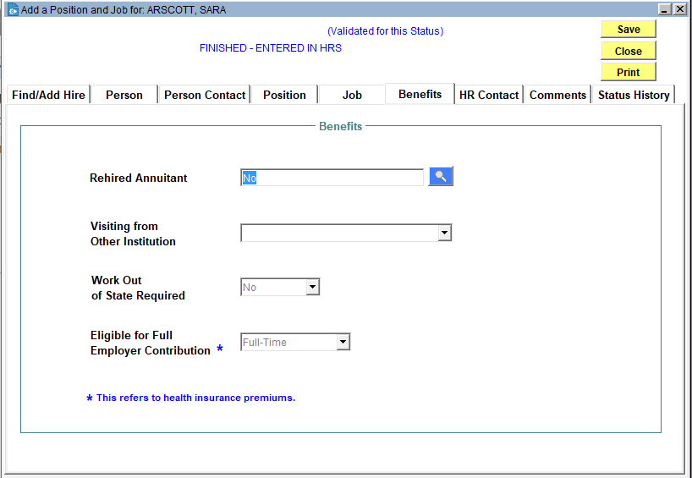

HR Contact Tab
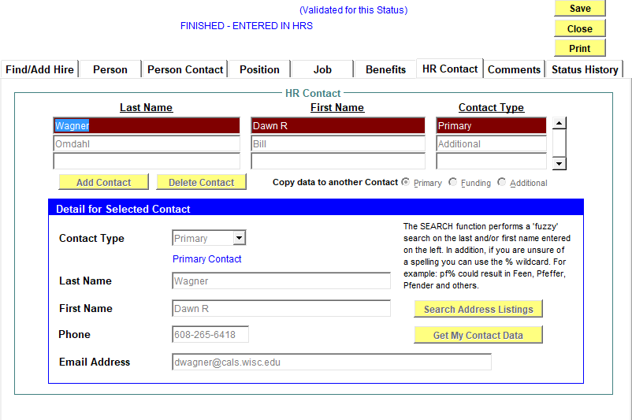

Comments Tab
Please add each piece of information as a separate comment (click “New Comment” for each item)
- Citizenship information –indicate specific Visa information
  - Typical Visas include: J-1, F-1 w/OPT, J-2, F-2
  - Note: A B Visa does not qualify for an $0 Honorary Associate appointment
- Location: UW-Madison, remote collaboration, or combination of both, other? Please identify the location of the remote collaboration. For example: Remote collaboration - accepted Post-Doc position in Berkeley, CA
  - Note: if appointee is remaining in their home country, Visa information is not required
- Support:
  - Generally, proof of financial support is required for foreign nationals; maintained at Unit level
  - If the individual is supported by an extramural funding such as a scholarship, fellowship or grant, please identify by award name
- Collaboration: examples are provided below:
  - Collaboration with Dr. NAME to [briefly describe research/responsibilities]
    - and completing manuscripts/publications
    - while employed at [e.g., DNR, USDA, USDA-ARS]
    - after recently graduating from UW in MM/YY
    - while taking a sabbatical from home institution
  - Training in the area of [briefly describe specific training]

