Furlough Obligation Report
To monitor furlough obligation, furlough hours used, and remaining furlough, run the Furlough Obligation report available in JEMS Hire. To request access to JEMS Hire, complete the JEMS Authorization form.

Run the Report
- From the Tools menu, select Furlough Obligation.
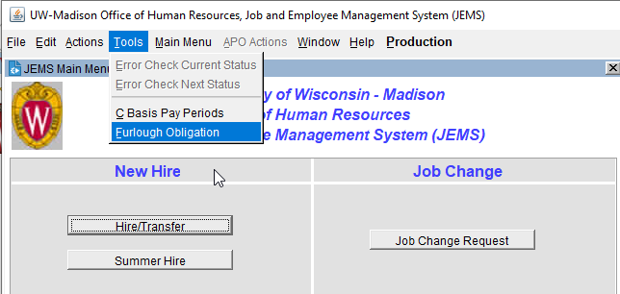

- The report can be run by Division/Department/Sub-department or for an Employee. Enter your criteria.
- Click Submit.

- Export data to Excel by clicking Print List at the bottom of the screen.

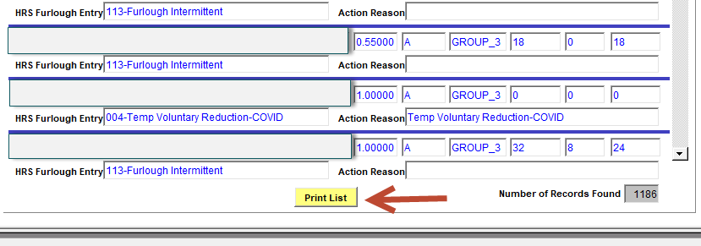

Considerations:
- Report data is current as of the previous day (tied to EPM data).
- Future dated hires, with effective dates prior to 10/31, will display the following day after entry in HRS.
- Obligation Hours are calculated and adjusted based on:
  - Hire date
  - Future dated changes (FTE and obligation increase or decrease due to rate change)
  - Terminations
- Employees moving from one job to another, that results in a Group change, will be flagged for HR Review.
  - Will appear on the new department’s report
  - Coordination between departments will be needed
- Does not adjust furlough obligation based on Expected Job End Date (EJED).
- Furlough takes that have been Approved, including future dated, are reflected in the Furlough Hours Used column.
- Data can be filtered after exporting to Excel.

Field Descriptions:
Column | Description
Person Name | Name
Empl ID/Rec | Employee ID/Employee Record
DeptID | Department ID
DeptID Descr | Department Description
Position Number | Position Number
FTE | FTE
Furlough Group | Furlough Group – Most recent effective dated furlough row in HRS. Displays for all listed employees.
Obligation Hours | Hours of furlough - Calculated as of current date
Furlough Hours Used | Furlough Hours – Approved furlough takes  *Group 1 will indicate “Reviewing” until data is available
Hours Remaining | Obligation Hours less Furlough Hours Used
HRS Furlough Entry | Furlough type entered in Job Data (see HRS Furlough Entry table)
Additional Detail | Information relative to furlough obligation and calculations (see Additional Detail table)

HRS Furlough Entry
HRS Furlough Entry | Description
004-Temp Voluntary Reduction-COVID | Temporary salary reduction - no additional furlough obligation
113-Furlough Intermittent | Intermittent Furlough (Group 3)
113-Temp Work Reduction/FTE-COVID | Position Specific Furlough including Work Share
114-Furlough Consecutive | 100% Consecutive Furlough
118-COVID Salary Reduction-%Type1 | Intermittent Furlough with Percent Smoothing (Groups 1 & 2)
119-COVID Salary Reduction-%Type2 | Intermittent Furlough with Percent Smoothing (Groups 1 & 2)
120-COVID Salary Reduction-%Type3 | Intermittent Furlough with Percent Smoothing (Groups 1 & 2)
121-COVID Salary Reduction-%Type4 | Intermittent Furlough with Percent Smoothing (Groups 1 & 2)

Additional Detail
Additional Detail | Description
E-3 Holder* | Exempt from Furlough
End Before 8/16/2020 | C-basis job with a term date prior to the start of fall semester
H1B* | Exempt from Furlough
Leave | Job on Leave of Absence
Needs HR Computation (GROUP CHANGE) | Furlough Group change - requires manual calculation
Temp Voluntary Reduction-COVID | Temporary salary reduction - no additional furlough obligation
Trades | Trades
*This relies on data as of May 15. For employees with E-3 or H1B visa hired after May 15, send an email to furlough@ohr.wisc.edu to have this information reflected in the JEMS Furlough report

Last Revised: 08/12/2020

