UW Madison Box
Login with NetID and password to uwmadison.box.com

A. Upload Files and Folders

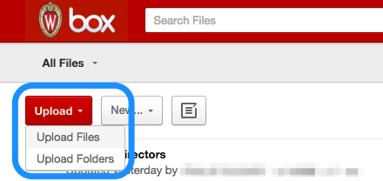

1. Click Upload and select upload files or folders
2. Use file-picker to select the needed file or folder

C. Invite others to join Folders

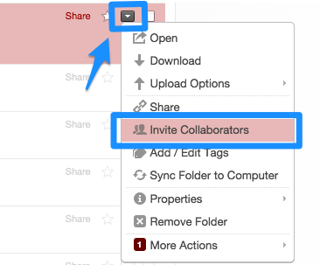

1. Click on next to the folder
2. Select Invite Collaborators
3. Type in Name or email address
4. Set Permission level
5. Send invite
General Notes
- Folders respect the Parent-Child folder structure, meaning if someone is added to the main folder, they can see all subfolders. When additional subfolders are added, all current collaborators will see them.
- Email notifications can be set at the all-folders level or at the single folder level.

B. Share Links to Files and Folders
For more information, see KB Doc #45368

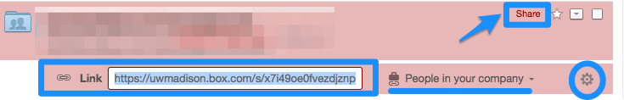

1. Click the word Share next to the file or folder
2. Set the level of access for the link:
People in your company = UW NetID required
People with the link = anyone in the world
3. Click on the to set any other link settings:
Custom URL, expiration date, etc.
4. Copy and paste the link where needed

D. Edit Files directly in Box
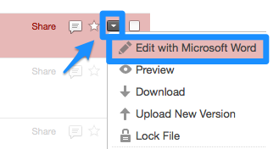

Note: The first time, install Box Edit
1. Click on next to the file
2. Select Edit with [MS Word, Excel, etc.]
3. Option: Lock file to prevent others from editing
3. Make needed edits
4. Save

