

**WSC Newsletter**

**President’s Message**

Hello WSC Members:

It is time, once again; for some WSC materials to come your way.

This winter we plan to release some pre-recorded presentations from friends of the society and we will offer CE with this as well. We also plan to host a socially distanced get together located somewhere between Madison and Milwaukee.

Please keep an eye on our social media, emails, and/or our website for more announcements related to these events!

I am calling once again for new volunteers to take seats on our board. We are currently in a holding pattern with several seats vacant or filled with wonderful and gracious members who have served over the time allotted by our charter. Once we are able to plan a more formal in-person meeting we will need more people to help make such an event possible. Please consider joining the board or spreading to word to sign up for membership.

Contents

President’s Message 1

UW Cytology Program Report 2

Fall Meeting 3

WSC Treasurer’s Report 4

WSC Meeting Minutes 5-6

WSC 2021 Membership List 7-8

Speaking of our membership, I would just like to say thank you once again! Your continued support has sustained us over this difficult time and we can’t wait to see you all again.

Kind Regards,

Joshua Faulkes CT(ASCP)CM, WSC President, WSC Webmaster

**Class of 2020-2021**The UW Madison Cytotechnology Program recently sent several graduates into the field!  
There were Ten students in last year’s cohort and they made us all proud. Due to Covid restrictions early in the year Microscopes and slide sets had to be shipped or picked up along with several sets of slides. Learning was entirely virtual until late spring, this involved moving all curriculum online, including Lectures, daily work, tests, and meetings. Luckily enough the State Lab also had a good-sized library of virtual slides which could be assigned remotely. This year was particularly difficult for students who had to obtain all feedback online, which is easy enough on a written test, but requires a virtual meeting or lots of photos to discuss a slide.  
  
Highlight of the year include:

**WSC Executive Board**

**President**

Joshua Faulkes

UW-Madison/WSLH

Madison, WI

[Joshua.faulkes@slh.wisc.edu](mailto:Joshua.faulkes@slh.wisc.edu)

**Vice President**

Traci Arts

UW-Madison/WSLH

Madison, WI

[traci.arts@slh.wisc.edu](mailto:traci.arts@slh.wisc.edu)

**Secretary**

Teri Stewart

UW Health

Madison, WI

Stewart Theresa A [TStewart2@uwhealth.org](mailto:TStewart2@uwhealth.org)

**Treasurer**

Lisa Ring

Columbia-St.Marys

Milwaukee, WI

[lisa.ring@gmail.com](mailto:colleen.stowe@gmail.com)

**Membership Director**

Elizabeth Haas

Wisconsin State Lab of Hygiene

Madison, WI

[wscmembershipdirector@gmail.com](mailto:wscmembershipdirector@gmail.com)

**Scholarship Director**

Kelly O’Mahar

Columbia St. Mary’s

Milwaukee, WI

[Kelly.omahar@ascension.org](mailto:Kelly.omahar@ascension.org)

**Newsletter Editor**

Stephen Berger

ACL Laboratories

Milwaukee, WI

[Stephen.Berger@Aurora.org](mailto:Kala.Mangiulli@ascension.org)

**Webmaster**

Open

|  |  |  |
| --- | --- | --- |
|  | **WSC Executive Board** |  |
|  |  |  |
|  | **President** |  |
|  | Angie Wortuba |  |
|  | **UW Hospital and Clinics** |  |
|  | **Madison, WI** |  |
|  | [angieetzel@gmail.com](mailto:angieetzel@gmail.com) |  |
|  |  |  |
|  | **Treasurer** | **Secretary** |
|  | Lisa Ring | Leah Schultz |
|  | Wisconsin Diagnostic Laboratories | Northwestern Medicine Central DuPage Hospital |
|  | Milwaukee, WI | Winfield, IL |
|  | [colleen.stowe@gmail.com](mailto:colleen.stowe@gmail.com) | [Leah.Schultz@nm.org](mailto:Leah.Schultz@nm.org) |
|  |  |  |
| **Membership Director** | **Scholarship Director** | **Newsletter Editor** |
| Elizabeth Haas | Kelly O’Mahar | Stephen Berger |
| Wisconsin State Lab of Hygiene | Columbia St. Mary’s | ACL Laboratories |
| Madison, WI | Milwaukee, WI | Milwaukee, WI |
| [wscmembershipdirector@gmail.com](mailto:wscmembershipdirector@gmail.com) | [Kelly.omahar@ascension.org](mailto:Kelly.omahar@ascension.org) | [Stephen.berger@aurora.org](mailto:Stephen.berger@aurora.org) |
|  |  |  |
|  | **Webmaster** |  |
|  | Joshua Faulkes |  |
|  | UW-Madison/WSLH |  |
|  | Madison, WI |  |
|  | [Joshua.faulkes@slh.wisc.edu](mailto:Joshua.faulkes@slh.wisc.edu) |  |

Jessica Konopatski winning the Zeiler Award  
Valeria Navarro and Jessica Konopatski, Co-Winners of the WSC Scholarship

Finally screening on-site and being able to attend a full rotation at UW-Health and SSM- Health over the summer.

**Congratulations to the class of**

**2021 UW Cytotechnology Program Scholarship Recipients!**

**Valeria Navarro** - 4.0 GPA student at UW-Madison, enrolled in the Cytotechnology Program. She had to pay the out of state tuition cost (which is almost three times the amount of in-state tuition), and had relied on FAFSA this school year in addition to all four years of her undergrad. Even with this debt, and the obstacles of COVID-19, she had excelled in the program and was recommended by the Medical Director for the WSC scholarship.

**Jessica Konopatski** - 4.0 GPA student at UW-Madison, enrolled in the Cytotechnology Program. She worked at a preclinical medical device testing facility that specializes in gene therapy development and other pharmaceuticals all through 2020. In 2021 a different medical device company reached out to her, which is where she currently works from home. She also has a weekend position as a microbiology quality control technician at a sandwich factory. She works 7 days a week while going to school online full-time. She has excelled even with the obstacles of COVID-19 and her BUSY work schedule.

Fall/Winter 2021 WSC Meeting

In spring of 2020 it was decided that a traditional Hotel-based meeting would not be prudent. We still would like to offer the opportunity to see fellow professionals outside of work.  
  
Please keep in mind that masking is still in effect in Dane Co. unless you are dining. If you do plan to attend this event, please make sure you are vaccinated or tested 1-2 days in advance for SARS-Cov 2 (Covid 19)

Where: Octopi Brewing Company

1131 Uniek Dr, Waunakee, WI 53597

When: December 11th at 5pm

Who: All Members are welcome for light socializing and frivolity

|  |  |  |  |  |  |
| --- | --- | --- | --- | --- | --- |
| **WSC TREASURER'S REPORT** | | | | | |
| DATE |  |  |  |  | **1/12/2021** |
| TOTAL BEGINNING BALANCE | | | |  | **$10,161.30** |
|  |  |  |  |  |  |
| REGISTRATION | |  |  |  |  |
|  |  |  |  |  |  |
| EXPENSE TOTAL | | |  |  | **0.00** |
|  |  |  |  |  |  |
|  |  |  |  |  |  |
|  |  |  |  |  |  |
| DEPOSIT TOTAL | | |  |  | **0.00** |
|  |  |  |  | **NET** | **0.00** |
|  |  |  |  |  |  |
| MEMBERSHIP | |  |  |  |  |
|  | **REFUNDS FOR 2020 MEMBERSHIP** | | | | **-63.00** |
|  | **PAYPAL FEES** | |  |  | **-44.04** |
|  | **STUDENT SCHOLARSHIP AWARDS** | | | | **-1000.00** |
|  |  |  |  |  |  |
|  |  |  |  |  |  |
| EXPENSE TOTAL | | |  |  | **-1107.04** |
|  | **PAYPAL PAYMENTS RECEIVED** | | | |  |
|  | **(MEMBERSHIP DUES)** | | |  | **1373.25** |
|  | **ACORD FUNDS RECEIVED FOR SCHOLARSHIP** | | | | **500.00** |
|  |  |  |  |  |  |
| DEPOSIT TOTALS | | |  |  | **1873.25** |
|  |  |  |  | **NET** | **766.21** |
|  |  |  |  |  |  |
| TOTAL ENDING BALANCE | | | |  | **10927.51** |
| DATE |  |  |  |  | **10/16/2021** |
|  |  |  |  |  |  |
|  |  |  |  |  |  |
|  | $1658.07 PAYPAL TRANSER HAS NO EFFECT ON TOTAL BALANCE | | | | |

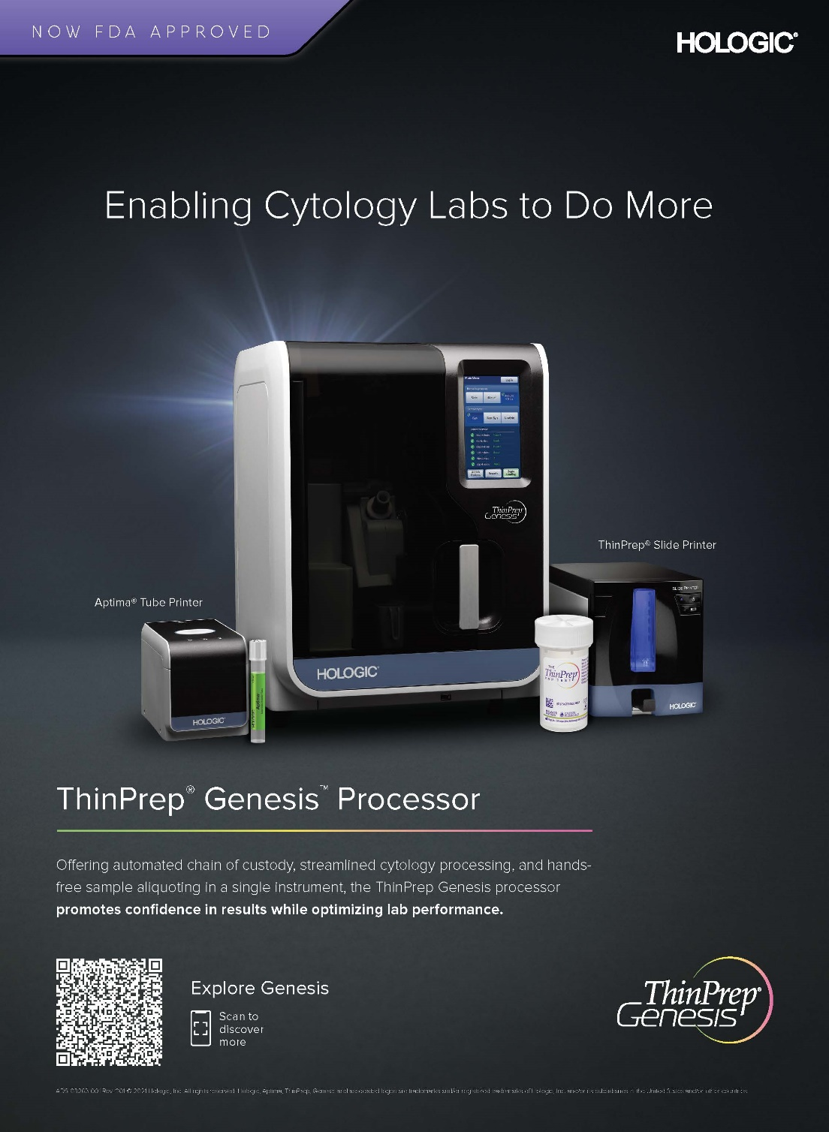

Wisconsin Society of Cytology Business Meeting

May 13, 2021, Conducted virtually due to pandemic

Present: Liz Haas, Josh Faulkes, Teri Stewart, Lisa Ring, Kelly O’Mahar, Stephen Berger, Traci Arts

Josh called the meeting to order at 11:00 AM.

Board Member Reports

Secretary’s Report: No current secretary. Teri Stewart has volunteered to take notes.

Scholarship Director’s Report: We have two great applicants: Valeria Navarro and Jessica Konopatski. Both have 4.0’s and have had difficult, expensive years while living away from home during a pandemic. Without having held in-person meetings for a couple of years, the account has plenty of funds for two scholarships. A motion was made to give both candidates $500 scholarships. All agreed and the motion passed. Dr. Aparna Mahajan donated her $100 honorarium. The funds will come from the WSC fund and the Acorn fund for the scholarships.

Membership Director’s Report: Liz has agreed to remain in the position. She hopes membership will pick up once the pandemic is over, and we can have in-person meetings again. There are currently 42 paid members, 11 honorary members and 10 students.

Treasurer’s Report: Presented in newsletter; As of 1/12/2021 account balance is 10161.30.

Newsletter Director’s Report: Stephen Berger has agreed to remain in his position.

Vice President’s Report: Traci Arts will remain in the position. She would like to remind us to thank the vendors and encourage people to watch the Hologic presentation since they sponsored our meeting.

Webmaster Report: There currently is no webmaster. If anyone knows any cytotechnologists who would like to take over this position, please let Josh know. He can meet with them and help them set it up.

Business

Elections- A motion was made to open elections.

President: Josh will remain the President till Spring 2022 per the constitution.

Vice President: A motion was made to make Traci Arts the emergency appointee Vice President. The motion passed.

Secretary: A motion was made to make Teri Stewart the emergency appointee Secretary. The motion passed.

Scholarship Director: Kelly O’Mahar will remain as the scholarship director.

Webmaster: this position is still open

Membership: Liz Haas will continue in this position.

Newsletter Editor: Stephen Berger will continue in this position.

A motion was made to close elections. Motion passed.

Candidates for Honorary Membership: A discussion was had on awarding honorary memberships. Per the constitution: Section 3. Honorary Members: An honorary member shall be any person who has made an outstanding contribution to the field of cytotechnology or to the Wisconsin Society of Cytology. This status shall be attained by appointment of the Executive Board.

A motion was made for John Shalkham to be made an Honorary Member. Motion passed.

Other candidates mentioned were Charmayne McGuire, Michele Smith and Araylla Hennigar. Discussion of these candidates was moved till the next business meeting.

Future Meetings:

Future meetings were discussed. With the pandemic, it was thought that in-person meetings might need to be put off. Stephen Berger suggested a hybrid meeting. With most of the board living in Madison it was thought that it might be best to hold the hybrid meeting in Madison and then the spring meeting at an away site. Holding the spring meeting in Madison would make it easier to have access to the technology to hold it in a hybrid fashion. It was suggested holding the spring 2022 meeting in Green Bay. It might be possible to have it hybrid as well. It was mentioned that the Fall 2022 could be held in Milwaukee.

Next business meeting will be held in June.

A motion was made to adjourn the meeting at 11:45. It passed

2021 WSC Membership

Membership dues paid in 2020 will be carried forward to cover 2021 dues. Those who have paid 2020 dues as well as 2021 will be issued a refund. Active members, in good standing, are eligible to vote or be elected to the Executive Committee. If you are interested in obtaining/maintaining your membership, please complete a membership form and submit it along with your $15.00 payment to:

Elizabeth Haas

WSC Membership Director

25 Sherman Terr #2

Madison, WI 53704

A copy of the membership form is available on our website at www.wisconsincytology.org under the “About us” tab. Dues may also be paid online using PayPal. If you have any questions, please feel free to contact our Membership Director, Elizabeth Haas by email at wscmembershipdirector@gmail.com.

Current Member List

|  |  |  |  |  |  |  |  |  |  |  |  |  |  |  |  |  |  |  |  |  |  |  |  |  |  |  |  |  |  |  |  |  |  |  |  |  |  |  |  |  |  |  |  |  |  |  |  |  |  |  |  |  |  |  |  |  |  |  |  |  |  |  |  |  |  |  |
| --- | --- | --- | --- | --- | --- | --- | --- | --- | --- | --- | --- | --- | --- | --- | --- | --- | --- | --- | --- | --- | --- | --- | --- | --- | --- | --- | --- | --- | --- | --- | --- | --- | --- | --- | --- | --- | --- | --- | --- | --- | --- | --- | --- | --- | --- | --- | --- | --- | --- | --- | --- | --- | --- | --- | --- | --- | --- | --- | --- | --- | --- | --- | --- | --- | --- | --- |
| |  | | --- | | Stephen Berger | | Terri Broxmeyer | | Holly Buettner | | Jillian Cascini | | Dr. James Caya | | Sharon Childs | | Selena Corbett | | Janice Costales | | Ruth Defries | | Marlene Doescher | | Tracie Drew | | Shawna Engelhardt | | Brittany Engels | | Josh Faulkes | | Kirsten Fries | | Elizabeth Haas | | Molly Hansen | | John Heinzl | | Patrick Helfenbein | | Kim Hellendbrand | | Katie Hughes | | Dr. Stanley Inhorn | | Maria Janssen | | Donna Kincaid | | Emalee Koch | | Leslie Koch | | Darla Koshnick | | Claudia Kraus | | Beverly Kurlinski | | Krystal Learned | | Aparna Mahajan, MD | | Charmayne McGuire | | Barbara Miller | | Kayo Miyazaki | | Laura Mueller | | Mike Myren | | Sonya Naryshkin, MD | | Emilee Nissen | | Kelly O'Mahar | | Lisa Ring | | Elizabeth Schroeder | | Jamie Schueller | | Nicole Schuh | | Brenda Schultz | | Leah Schultz | | Gretchen Segal | | Sandy Sherman | | Natasha Sichula | | Edith Smith | | Jimmie Stewart | | Karen Stitch | | Colleen Stowe | | Judy Theisenhausen | | Nancy Wade | | Donna Wetzel | | Changhong Ye |  |  | | --- | | **Student members**  Supriya Agarwal (2021) | | Natalie Carter (2021) | | Elle Freeders (2021) | | Jess Konopatski (2021) | | Valeria Navarro (2021) | | Jared Otterlee (2021) | | Jen Proud (2021) | | Piayeng Thao (2021) | | Amberly Velasquez (2021) | | Ryan Yost (2021)  Hannah Kotz (2022) |   Hana Sleiman (2022)  Allison Carter (2022)  Ellen Trombla (2022)  Morgan Deuster (2022)  Tyler Hagen (2022)  Taylor Meyer (2022)  Weiying Yue (2022) |