Zero Dollar Honorary Associate –
Unit Request Process

Background:
- $0 Honorary Associate/Fellow (Z90NN): This title designates the holder of a fellowship (usually postdoctoral) administered outside the University or a courtesy appointment for a visiting scholar. This temporary appointment is used to provide an official University affiliation and identification without pay
- Appointment duration can be requested for a maximum of three years with the option to extend, pending CALS HR approval

 | Task | Notes
☐ | Unit checks HRS Legacy to confirm individual has not had a previous appointment; if previous appointment, use empl ID in JEMS transaction
☐ | Unit initiates request in JEMS Hire (see following steps and Job Aid for more information)  - Ensure name entered in JEMS matches documentation (Driver’s License, Passport, etc.) that individual will bring to Wiscard office; it’s critical that the name in HRS matches otherwise a Wiscard won’t be issued  - FYI:  - Wiscard will not be granted more than 7 days before the effective date  - CALS HR will request NetID  - Notes:  - During calendar year changes, please be aware of the 3-year maximum appointment duration (e.g. 1/1/2020-12/31/2023 is 4 years)  - A $0 Honorary Associate appointment is considered an active appointment for purposes of the ETF 75 day waiting period
☐ | Unit ensures the following information is entered in the Person section:  - DOB and SSN are required (documentation is required for an SSN exception)  - If the appointee does not have an SSN, the Foreign National box should be checked
☐ | Unit ensures the following information is entered in the Position section:  - Empl Class: OT4  - Jobcode/title: Z90NN Honorary Associate/Fellow  - FTE: 0  - HR Dept: Location should be the Unit’s campus address, not Ag Hall  - FLSA status: default  - “Reports to”: This is the faculty mentor. A mentor must have an active appointment in HRS. For example, a $0 appointment as an Emeritus Professor (D21NN) is an active appointment. Having emeritus status with UW is an honorary designation and does not qualify as an active appointment. The CALS HR supervisor change process applies when a mentor ends their employment with UW.
☐ | Unit ensures the following information is entered in the Job section:  - A CBC is not required  - Pay basis: No Pay Basis
☐ | Unit includes the following information in the Comments section:  Please add each piece of information as a separate comment (click “New Comment” for each item)  - Citizenship information –indicate specific Visa information  - Typical Visas include: J-1, F-1 w/OPT, J-2, F-2  - Note: A B Visa does not qualify for an $0 Honorary Associate appointment  - Location: UW-Madison, remote collaboration, or combination of both, other? Please identify the location of the remote collaboration. For example: Remote collaboration - accepted Post-Doc position in Berkeley, CA  - Note: if appointee is remaining in their home country, Visa information is not required  - Support:  - Generally, proof of financial support is required for foreign nationals; maintained at Unit level  - If the individual is supported by an extramural funding such as a scholarship, fellowship or grant, please identify by award name  - Collaboration: examples are provided below. Units can include one or more of the below or customize the request.  - Collaboration with Dr. NAME [briefly describe research/responsibilities]  - and completing manuscripts/publications  - while employed at [e.g., DNR, USDA, USDA-ARS]  - after recently graduating from UW in MM/YY  - while taking a sabbatical from home institution  - Training in the area of [briefly describe specific training]  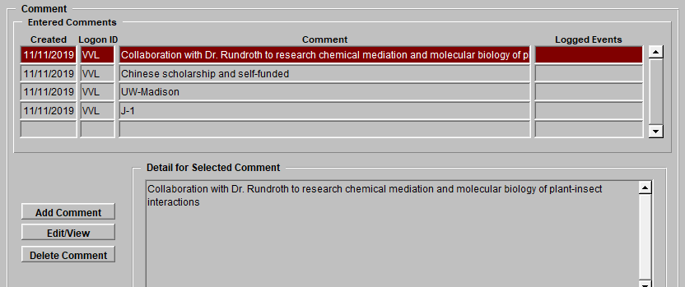
☐ | Unit emails up-to-date resume to assigned CALS HR team  Note: A current resume reflects recent graduation dates, accepted positions, end dates for a recent RA or other appointment with UW, new employment, etc.
☐ | CALS HR will review and approve JEMS request, push hire to HRS, and issue appointment letter with attachment to Unit indicating approval of appointment.
☐ | Unit provides letter to appointee with attachments
☐ | For changes in start date or end date, Unit uses JEMS Jobs Change to submit request  Please identify reason for the start or end adjustment in the Comments section  CALS HR will review and approve JEMS request, ensure change is entered in HRS, and issue revised appointment letter  Unit provides revised letter to appointee with attachment
☐ | For end date extensions, Unit uses JEMS Jobs Change to submit request and submits an updated resume to CALS HR (unless appointee is on a J-1 as part of their PhD program)  If any of the following have changed, please identify the changes in the Comments section:  - Change in mentor or research collaboration  - Visa status change  - Location of appointee (remote, local)  - Financial support  If there are no changes, insert the following in the Comments section:  - “This is an extension request and no changes have occurred since original appointment”  CALS HR will review and approve JEMS request, enter change in HRS,  and issue appointment extension letter with attachment.  Unit provides extension letter to appointee with attachment

