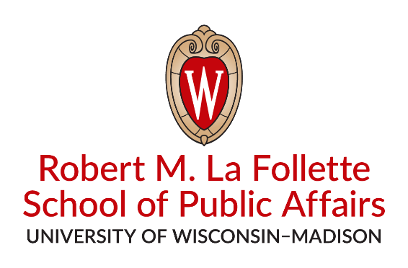  Workshop Policy Brief  Date  Prepared for Client Name  By  Author 1 (alphabetical)  Author 2  Author 3  Author 4  The full report is available at http://www.lafollette.wisc.edu/outreach-public-service/service-learning  Robert M. La Follette  School of Public Affairs  1225 Observatory Drive  Madison, WI 53706  608-262-3581  info@lafollette.wisc.edu |  | Spring 2018  Title of report  Workshop in International Public Affairs. Workshop in Public Affairs. Workshop in International Public Affairs. Workshop in Public Affairs. Workshop in Public Affairs. Workshop in Public Affairs. Workshop in Public Affairs. Workshop in Public Affairs. Workshop in International Public Affairs.  Workshop in International Public Affairs. Workshop in Public Affairs. Workshop in International Public Affairs. Workshop in Public Affairs. Workshop in Public Affairs. Workshop in Public Affairs. Workshop in Public Affairs. Workshop in Public Affairs. Workshop in International Public Affairs.  Workshop in International Public Affairs. Workshop in Public Affairs. Workshop in International Public Affairs. Workshop in Public Affairs. Workshop in Public Affairs. Workshop in Public Affairs. Workshop in Public Affairs. Workshop in Public Affairs. Workshop in International Public Affairs.  Workshop in International Public Affairs. Workshop in Public Affairs. Workshop in International Public Affairs. Workshop in Public Affairs. Workshop in Public Affairs. Workshop in Public Affairs. Workshop in Public Affairs. Workshop in Public Affairs. Workshop in International Public Affairs.  Workshop in International Public Affairs. Workshop in Public Affairs. Workshop in International Public Affairs. Workshop in Public Affairs. Workshop in Public Affairs. Workshop in Public Affairs. Workshop in Public Affairs. Workshop in Public Affairs. Workshop in International Public Affairs. Workshop in International Public Affairs. Workshop in Public Affairs. Workshop in International Public Affairs.  Workshop in International Public Affairs. Workshop in Public Affairs. Workshop in International Public Affairs. Workshop in Public Affairs. Workshop in Public Affairs. Workshop in Public Affairs. Workshop in Public Affairs. Workshop in Public Affairs. Workshop in International Public Affairs.  Workshop in International Public Affairs. Workshop in Public Affairs. Workshop in International Public Affairs. Workshop in Public Affairs. Workshop in Public Affairs. Workshop in Public Affairs. Workshop in Public Affairs. Workshop in Public Affairs. Workshop in International Public Affairs.  Workshop in International Public Affairs. Workshop in Public Affairs. Workshop in International Public Affairs. Workshop in Public Affairs. Workshop in Public Affairs. Workshop in Public Affairs. Workshop in Public Affairs. Workshop in Public Affairs. Workshop in International Public Affairs.

