Trophic Vertical Zonation in the Sandy Intertidal Zone of Sapelo Island, GA
Michael Spear

Introduction
Vertical zonation of intertidal communities is a hallmark of many ecology textbooks, as it can eloquently exemplify complex ecological concepts like environmental tolerances, niche formation, resource partitioning, and interspecific competition. It has been best studied in rocky intertidal systems, where a clear and exposed vertical gradient is present, upon which stark visual contrasts highlight the vertical zonation of floral and faunal communities (Connell, 1972; Grosberg, 1982; Menge and Lubchenco, 1981). Vertical zonation of sandy intertidal zones is far less studied, however. Complicated by the hidden nature of sub-surface invertebrate and algal communities, the dynamic substrate doesn’t lend itself to observations more easily performed on static, solid rock. This study takes a broader scope, describing the zonation of trophic levels, instead of taxonomy-heavy characterization of whole communities.
Primary production on a beach is limited to algae and diatoms on the epibenthic and interstitial regions of the sand, typically within 10cm of the surface (Asplund and Cottingham, 1991). Previous literature suggests a mid-shore height concentration of primary producer biomass, as photosynthesizing organisms position themselves halfway through the tidal cycle to optimize inundation, to prevent desiccation, and exposure, to absorb sunlight (Asplund and Cottingham, 1991).
Secondary producers graze these interstitial algae, and are composed of fauna from molluscs to crustaceans, but many feed on primary production brought in with the tide. To assess whether trophic levels zonate based on autochthonous production, the list narrows to protozoans, nematodes, chelicerates, polychaetes, and crustaceans (Flanders Marine Institute, 2009). However, Essington (1995), reports that >98% of fauna in the interstitial of Nannygoat Beach, Sapelo Island were amphipods, of the family Haustoridae (Croker, 1968), which graze algae and decaying microfauna (Massie, 1998). This statement was likely made with limited capacity to study anything much smaller than an amphipod. However, this study is interested in trophic zonation, and microfauna that could be missed in this estimation by Essington should be virtually immobile at the whole-beach scale. Therefore, any amphipod predation on microfauna would take place at the same relative shore height that primary production occurs anyways, making this link between primary producers and amphipods spatially irrelevant for food availability-driven zonation.
In this study, primary and secondary producer biomass density were analyzed along a shore-height gradient to detect vertical zonation patterns of either trophic group. Interstitial algae was selected to represent primary producers, and amphipods (Family Haustoridae) were selected to represent secondary producers. We hypothesized that both primary and secondary producer biomass would concentrate at mid-shore height, putatively driven by inundation/exposure optimization of primary producers, and food availability positioning of secondary producers.
Methods
One transect, perpendicular to the shore, was selected at Nannygoat Beach on Sapelo Island, Georgia (31.38993, -81.26453) (Figure 1). Ten samples were taken along the transect, approximately every 13m, at daytime low tide. The first sample was taken at the base of the dune. Sampling dates were 10/26/15, 10/28/15, and 10/29/15. The sample of highest shore height (closest to the dune) was above the high water mark on the first sample day, but was inundated by extremely high tides between days 1 and 2, and days 2 and 3. Runnels occurred between sample sites 4 and 5, and 7 and 8, with sample 1 being closest to the dune.
Primary producer biomass was estimated as chlorophyll-a concentration (ug/mL) per square meter, integrated over the putative vertical migration range of interstitial algae (10cm) (Asplund and Cottingham, 1991). A cylindrical core of sand (9cm diameter, 10cm depth) was taken at each sampling site along the transect. Sand was kept in a shaded jar. Primary producers from the interstitial were extracted by addition of 200mL water, vigorous shaking of the container, settling of sand particles, and decanting of 180 mL supernatant (containing interstitial primary producers) for filtration. This was repeated twice per sample, on the sample filter. Samples were filtered through Whatman GF/F glass microfiber filters. Filters were shaded and frozen for 12 hours for preservation and cell lysis, and then exposed to 25mL of 90% ethanol for 2 hours, shaken every half hour, for chlorophyll-a extraction. Chlorophyll-a was read on a spectrophotometer at 664 and 750nm. Absorbance readings were converted to ug/mL of chlorophyll-a using the standard equation from Marker et al. (1980), and then converted to ug/m² (integrated over the 10cm core) using the area of the beach that the corer sampled.
Secondary producer biomass was measured as dry mass of amphipods (Family Haustoridae) per square meter, also integrated over the vertical migration range of interstitial algae (10cm) (Asplund and Cottingham, 1991). A cylindrical core of sand (20cm diameter, 10cm depth) was taken at each sampling site along the transect. Sand was sifted on site with a 0.5mm mesh sieve, and amphipods were collected and preserved in refrigerated seawater until processing. Amphipods were exposed to 90% ethanol, counted, and dried at 60° C for 12 hours. Dry mass was recorded to the nearest mg, as the balance available below this resolution was unreliable.
Low sample size and unique observational design lend this project to visual interpretation of trends, but ANOVA’s were performed on primary and secondary producer biomass densities in groupings of high-, mid-, and low-shore height sampling sites. Groupings of sampling sites were assigned along the transect based on above the runnels=high (sites 1-4), between the runnels=mid (5-7), or below the runnels=low (8-10). The dry mass per individual amphipod was also analyzed by the same groupings, via ANOVA.
Results
All three sampling days returned very similar distributions of both primary and secondary producer biomass (Figure 2). Dampening of trends on Day 1 may be attributed to inconsistent sampling procedures that were worked out by Day 2.
Supporting our hypothesis, primary producer biomass densities appear greatest at mid-shore height, with small values at high and low-heights (Figure 3). There does appear to be a second peak of primary producers around 105m from the dune, though that is largely due to one outlier at sample site 9 on Day 3 (30.97 ug/mL/m²), nearly twice as high as any other sample from that location.
Contrary to our hypothesis, secondary producer biomass densities appear highest at higher shore heights, dropping off considerably after 50m from the dune (Figure 3). Although, no amphipods were found at the highest shore height sample, taken at the base of the dune, all three days. Nonetheless, the trend suggests a positive relationship between shore height and secondary producer biomass density. Again, one outlier (Site 4, Day 1, 0.056 mg/m²) adds some variance to an otherwise strong trend.
When grouped in three shore height categories (high, mid, low), the visual trends are upheld by statistics. ANOVA reports a mid-shore height peak of primary producer density (Figure 4), significantly greater than the samples closer or farther from the dune (p<0.001; Tukey’s HSD: mid:high p<0.001, mid:low p<0.05). The secondary producer biomass density trend is also supported by the statistics (Figure 4), with ANOVA reporting greatest densities at the highest shore heights (p<0.001; Tukey’s HSD: high:mid p<0.05, high:low p<0.001). ANOVA revealed no relationship between amphipod dry mass density per individual and shore height (p>0.1).
Discussion
Primary producer biomass densities aligned according to our hypothesis, with greatest dry mass per area at the mid-shore height. Literature suggests interstitial primary producers like algae and diatoms align themselves along this gradient to optimize inundation and exposure time, to allow for photosynthesis yet prevent desiccation (Aleem, 1950; Hopkins, 1964; McIntire, 1978). The literature confirms this trend. This study also demonstrates the resilience of this gradient to physical perturbations. Samples were taken at the highest tides of the year, making for intense tidal disturbances of even the highest shore-heights’ sand between sampling days. Despite these high tides, the interstitial primary producers displayed the same biomass density gradients all three days (Figure 2), indicating this trend is not easily offset by physical disruption.
We hypothesized that secondary producers, represented by the burrowing amphipods , would also have highest densities at mid-shore height, with lower densities at high- and low-shore height. However, they exhibited a much different trend. Though no amphipods were found at the base of the dune, they still congregated at the top of the beach and fell off near-linearly towards the ocean. This suggests that their distribution is not driven entirely by food availability. One possible explanation is if these amphipods don’t directly feed on the interstitial algae, despite that literature suggests that they do (Jansson, 1968). While they are known to also feed on washed up algal wracks (Massie, 1998), these types of subsidies are not a consistent part of the Sapelo Island beach dynamics, as observed during our sampling trip.
They could be feeding preferentially on decaying microfauna like nematodes and protozoans, but these animals are essentially immobile at this whole-beach scale, and are likely to exist along the same density gradient as the primary producers, as their ecologies are less complex and likely food-availability driven. This is complicated by the fact that amphipods can nocturnally migrate down the beach to forage/graze, potentially uncoupling their diurnal burrows from their food source, even if they are directly feeding on the interstitial algae. However, their distribution in one study was only altered by 3m during nocturnal migration (Geppetti and Tongiorgi, 1967), which is not a large difference on a beach of this scale. An exploration of microfaunal distribution, while too difficult to be accomplished in our time on the island, would be an important question to answer for understanding trophic vertical zonation, and would eliminate our assumption that amphipods act as secondary producers, at least at spatially relevant scales.
If not entirely food-availability driven, perhaps the amphipod distributions are dictated by wave-action avoidance. A high-beach congregation could imply the amphipods are retreating from the disturbances of the swash zone, as Essington suggests (1995). However, the high tide during our study days eclipsed the high-beach “refuge” of the amphipod distribution by tens of meters, indicating this is not a likely explanation during this time period. Also, amphipod vertical zonation patterns of Sapelo Island have been shown to withstand hurricanes, making ordinary wave action an unlikely driver of their normal distribution (Croker, 1968).
Another possible mechanism for this distribution is more precise control over desiccation stress. This is a little less intuitive, because amphipods need a moist, humid environment, and so the top of the beach, where exposure to the sun is highest, would seem counterproductive. However, free from inundation (most of the tidal cycle), amphipods could burrow vertically down into the sand to control water content of their surroundings, and literature suggests that they do (Williams, 1995). As they move down towards the water table, they could find more moist conditions without venturing further down the beach toward the ocean. This would be a more reliable method of reducing desiccation stress, as the distance to the water table is shorter and more consistent than following the tide in and out. By positioning themselves at the top of the beach, the moisture of the surroundings wouldn’t be complicated by tide for most of the day. Our measure of inundation time through shore height could also be imperfect, further complicating the relationship.
Other possible explanations for the biomass density trend seen in this study are optimal grain size for burrowing, and predator avoidance. Grain size accounted for variation in burrowing invertebrate distributions in one study, though amphipods were not part of this study (Wieser, 1959). Predator avoidance seems to provide stronger evidence as a driver of distribution. Forshay (2001) observed increased shorebird foraging in the swash zone, where amphipods appeared exposed by wave action. This could lead amphipods to burrow higher up the shore, to reduce time they are in the swash zone, though exposure of amphipods from swash seems to contradict other studies that observed amphipods unaffected by wave action. Another study observed sand-burrowing crustaceans, including
Haustoridae amphipods, as a major diet item of surf-zone fishes (Takahashi et al., 1999). Predation from these fish could also drive amphipod biomass density distributions further up shore.
While the distribution of primary producers seems to be consistent and well-explained by the literature, that of secondary producers, particularly our representative, the Haustoridae amphipods, is less clear. While most literature supports a high-beach distribution of biomass density, the mechanisms driving this distribution are unclear, and may be further complicated by potential nocturnal (Geppetti and Tongiorgi, 1967) and perhaps even seasonal migrations (Williams, 1995). Our selection of amphipods as representatives of the secondary trophic level made this study possible, as examination of microfauna was not accommodated by our time and resource limitations. However, it could have confounded potential relationships between trophic level distributions, as amphipods can feed on sources other than interstitial algae.
Understanding vertical zonation in sandy intertidal zones is important for our knowledge of coastal systems. Particular importance lies in conservation of endangered shorebirds that rely on a stable sandy intertidal ecosystem, and for our continued monitoring of rising sea levels with global climate change, and what that might mean for the health of these systems. Further research, especially at the species and community levels, is needed to bring our understanding of vertical zonation in sandy systems up to par with the more complete work on rocky systems.
Advice to Future Sapeloids
This study found strong evidence for zonation of these two organisms, but a true connection to trophic zonation was difficult to pin down. Further exploration of this topic could build on this work and develop a more comprehensive picture of vertical zonation in a sandy intertidal system. While species-level taxonomy and characterization of a community zonation would be most exciting, that kind of taxonomic work is not suitable for a project of this scope.
We suggest night-time sampling to better understand the nocturnal feeding migrations of amphipods in this system, as well as some type of observational work to determine the actual food items of these organisms. Further work on this topic during less extreme tides would give insight to the consistency of the trends found in this study. Exploration of other secondary producers could highlight trends in that trophic level that we missed by studying only amphipods, though amphipods seem to make up the vast majority of visible invertebrates, and more time-consuming microscope work would likely be required.
As for methodological advice, capturing amphipods proved best by packing a sieve with sand and gently shaking it in the runnel, keeping the rim of the sieve above the water to prevent loss of individuals. Once most of the sand has been sieved, I kept the sieve submerged and used a plastic eyedropper to suck up the live, moving amphipods.
Figures
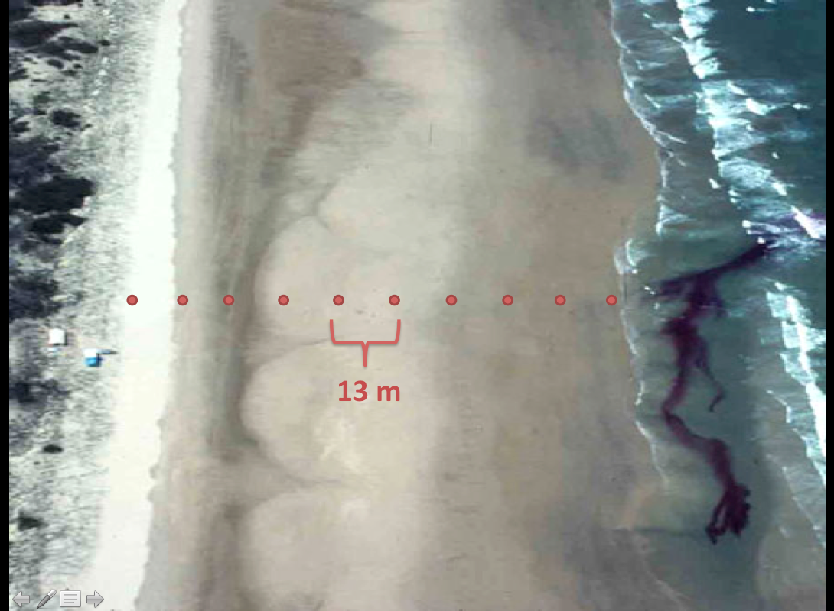
Figure 1. 10 samples, 13 m apart, were taken each of the three days along a transect perpendicular to the shore on Nannygoat Beach, Sapelo Island, GA.

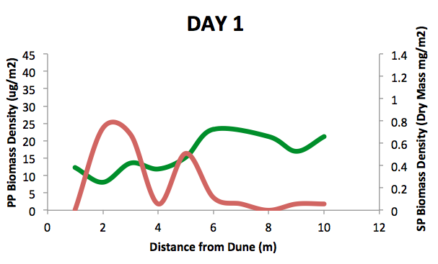
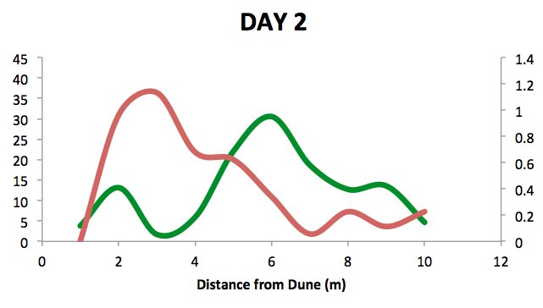
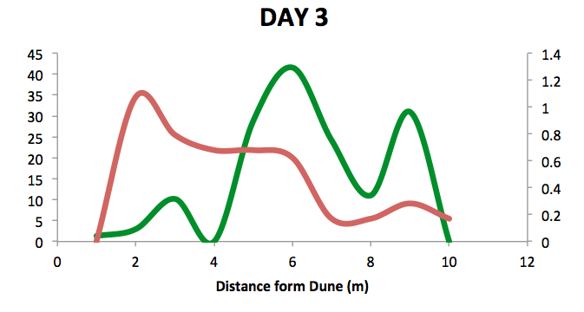
Figure 2. Samples of primary producer (green) and secondary producer (red) biomass density were taken on three days, every 13m from the base of the dune to the water line at low tide. Trends were consistent across sampling days.

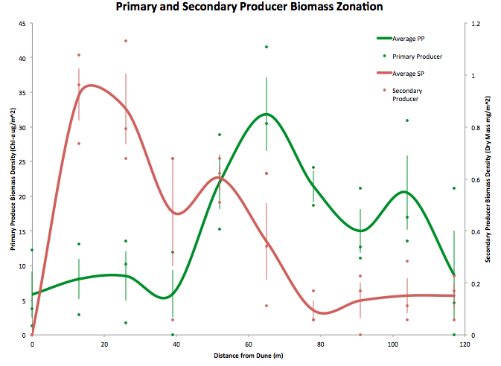
Figure 3. Primary producer (green) and secondary producer (red) biomass densities represented as a moving average (smooth lines). Dots represent individual samples from the three sampling days. Vertical lines indicate standard error of the mean from samples at that location.

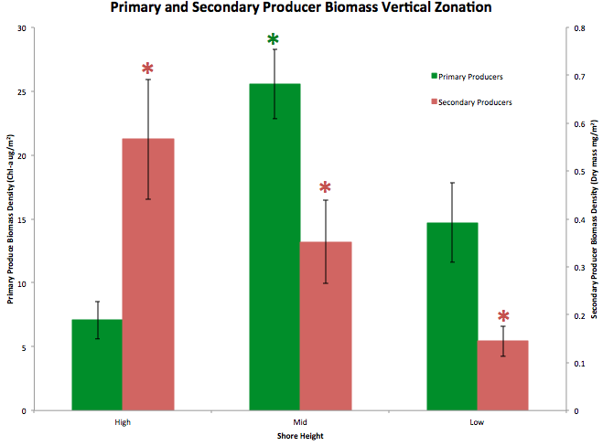
Figure 4. Samples were grouped by shore height based on relative position to the runnels on the beach (high=above, mid=between, low=below). Primary producer (green) and secondary producer (red) biomass densities exhibit the same trends as the moving average analysis. Asterisks indicate statistically significant distinction of that mean from the others of that trophic level.

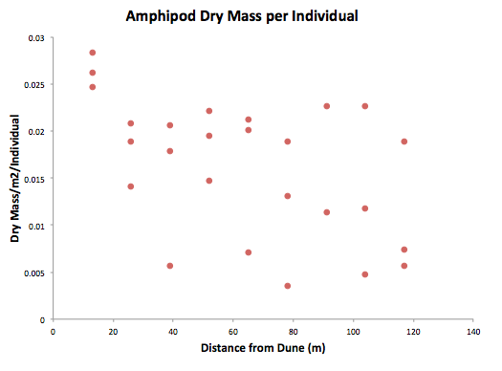
Figure 5. Amphipod dry mass in each sample was divided by the count of individuals from that sample. Amphipod dry mass per individual did not vary with shore height.

Literature Cited

Aleem, A. A. "the diatom community inhabiting the mudflats at Whitstable." New Phytologist 49.2 (1950): 174-188.
Asplund, Timothy R., and Kathryn L. Cottingham. “The Distribution and Vertical Migration of Interstitial Algae on an Intertidal Beach, Sapelo Island, Georgia, Using Chlorophyll a as an Indicator.” Unpublished UW Sapelo Project (1991).
Connell, Joseph H. "Community interactions on marine rocky intertidal shores." Annual Review of Ecology and Systematics (1972): 169-192.
Croker, Robert A. “Distribution and Abundance of Some Intertidal Sand Beach Amphipods Accompanying the Passage of Two Hurricanes”. Chesapeake Science 9.3 (1968): 157–162.
Essington, Tim. “Biotic and abiotic factors affecting the spatial distribution of sandy beach infauna.” Unpublished UW Sapelo Project (1995).
Flanders Marine Institute. “Meiofauna of Sandy Beaches.” (2009). <http://www.marbef.org/wiki/Meiofauna_of_Sandy_Beaches>.
Forshay, Kenneth. “Is shorebird foraging related the distribution of amphipods on a sandy beach of Sapelo Island, Georgia?” Unpublished UW Sapelo Project (2001).
Geppetti, Laura, and Paolo Tongiorgi. "Nocturnal migrations of Talitrus saltator (Montagu)(Crustacea Amphipoda)." Monitore Zoologico Italiano-Italian Journal of Zoology 1.1 (1967): 37-40.
Grosberg, Richard K. "Intertidal zonation of barnacles: the influence of planktonic zonation of larvae on vertical distribution of adults." Ecology(1982): 894-899.
Hopkins, J. T. "A Study of the Diatoms of the Ouse Estuary, Sussex II. The Ecology of the Mud-Flat Diatom Flora." Journal of the marine Biological Association of the United Kingdom 44.02 (1964): 333-341.
Jansson, Bengt-Owe. "Quantitative and experimental studies of the interstitial fauna in four Swedish sandy beaches." Ophelia 5.1 (1968): 1-71.
Massie, Frederick D. The Uncommon Guide to Common Life of Narragansett Bay. Save the Bay, Incorporated, Rhode Island. (1998).
McIntire, C. David. "The distribution of estuarine diatoms along environmental gradients: a canonical correlation." Estuarine and Coastal Marine Science 6.5 (1978): 447-457.
Menge, Bruce A., and Jane Lubchenco. "Community organization in temperate and tropical rocky intertidal habitats: prey refuges in relation to consumer pressure gradients." Ecological Monographs 51.4 (1981): 429-450.
Takahashi, Kazutaka, Taro Hirose, and Kouichi Kawaguchi. "The Importance of Intertidal Sand-burrowing Peracarid Crustaceans as Prey for Fish in the Surf-zone of a Sandy Beach in Otsuchi Bay, Northeastern Japan." Fisheries science 65.6 (1999): 856-864.
Wieser, Wolfgang. "The effect of grain size on the distribution of small invertebrates inhabiting the beaches of Puget Sound." Limnology and Oceanography 4.2 (1959): 181-194.
Williams, John A. "Burrow-zone distribution of the supralittoral amphipod Talitrus saltator on Derbyhaven Beach, Isle of Man: a possible mechanism for regulating desiccation stress?." Journal of Crustacean Biology (1995): 466-475.

